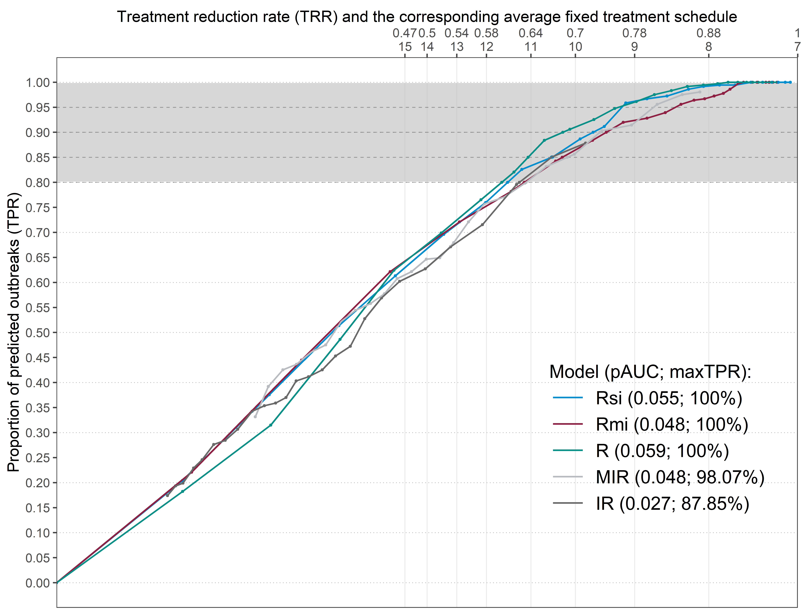

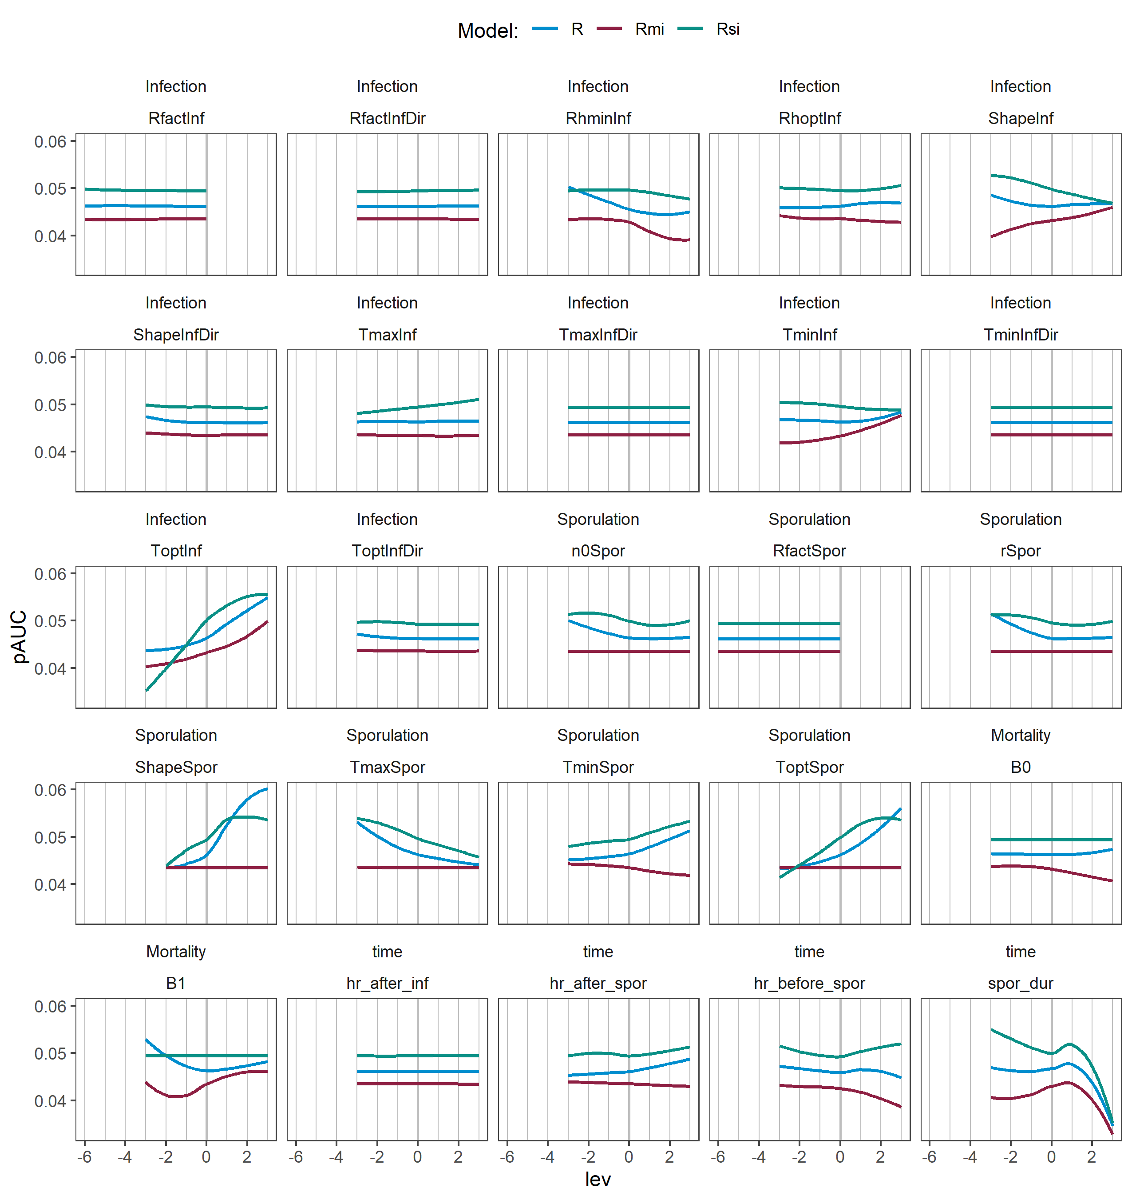

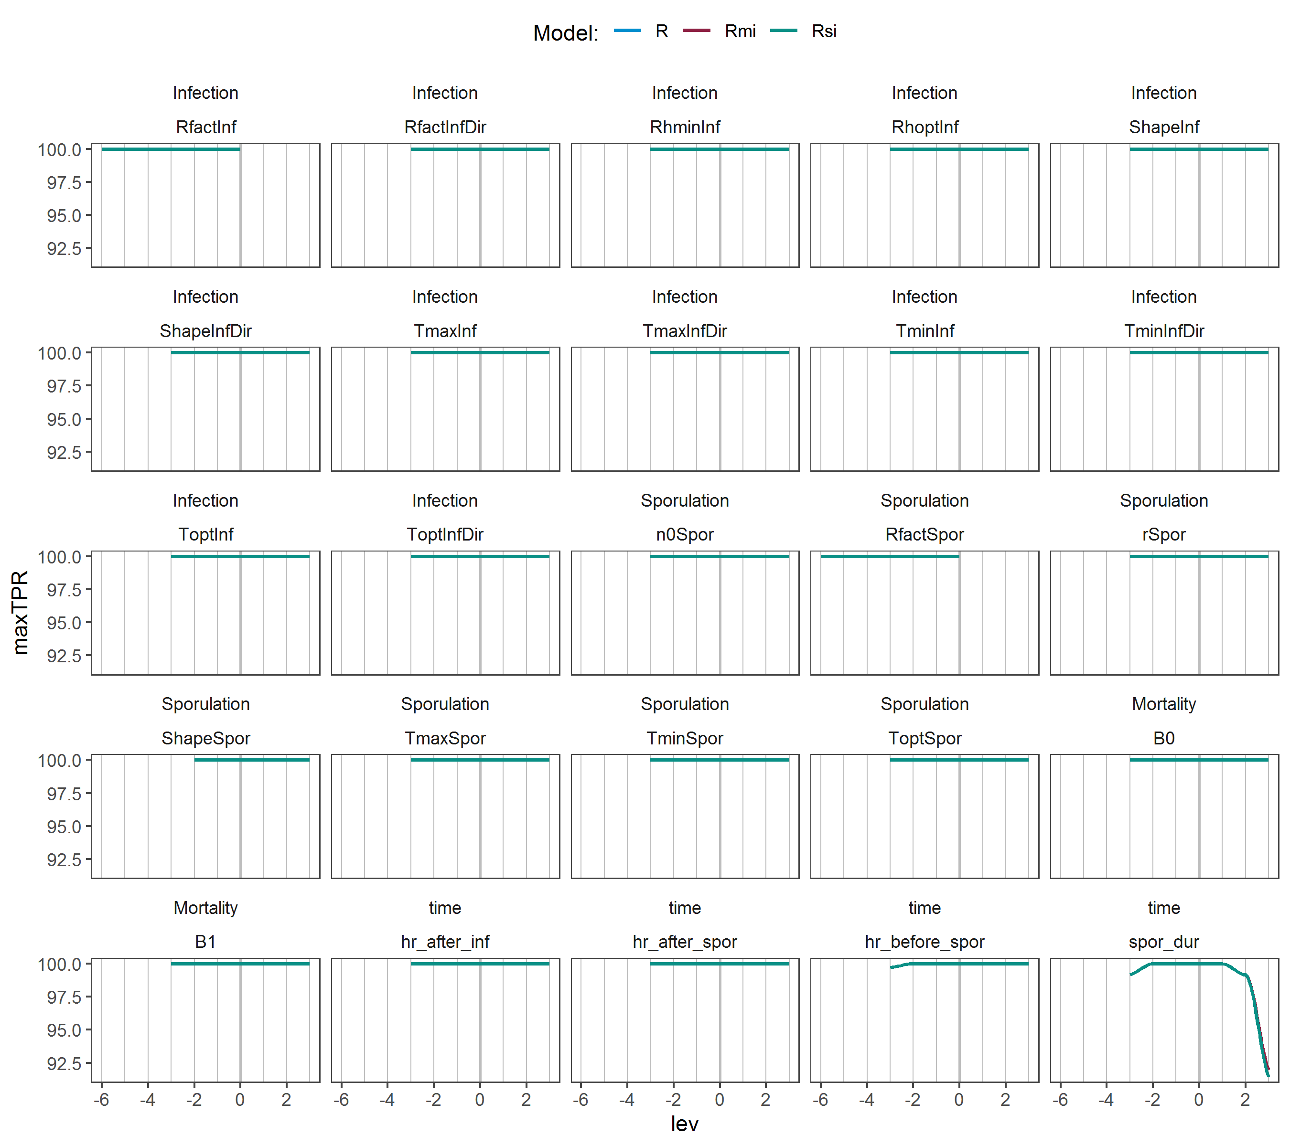

Table S1. Sensitivity analysis parameter values.

|  |  |  |  |  |  |  |  |
| --- | --- | --- | --- | --- | --- | --- | --- |
|  | Levels | | | | | | |
| Parameter | -3 | -2 | -1 | 0 | 1 | 2 | 3 |
| TminInf | 3 | 4 | 5 | 6 | 7 | 8 | 9 |
| ToptInf | 9 | 10 | 11 | 12 | 13 | 14 | 15 |
| TmaxInf | 23 | 24 | 25 | 26 | 27 | 28 | 29 |
| ShapeInf | 1 | 5 | 10 | 15 | 20 | 25 | 30 |
| TminInfDir | 3 | 4 | 5 | 6 | 7 | 8 | 9 |
| ToptInfDir | 18 | 19 | 20 | 21 | 22 | 23 | 24 |
| TmaxInfDir | 23 | 24 | 25 | 26 | 27 | 28 | 29 |
| RfactInfDir | 0.3 | 0.4 | 0.5 | 0.6 | 0.7 | 0.8 | 0.9 |
| ShapeInfDir | 1 | 5 | 10 | 15 | 20 | 25 | 30 |
| RhminInf | 83 | 84 | 85 | 86 | 87 | 88 | 89 |
| RhoptInf | 92 | 93 | 94 | 95 | 96 | 97 | 98 |
| B0 | 0.01 | 0.37 | 1.37 | 2.37 | 3.37 | 4.37 | 5.37 |
| B1 | 0.15 | 0.25 | 0.35 | 0.45 | 0.55 | 0.65 | 0.75 |
| TminSpor | 3 | 4 | 5 | 6 | 7 | 8 | 9 |
| ToptSpor | 17 | 18 | 19 | 20 | 21 | 22 | 23 |
| TmaxSpor | 23 | 24 | 25 | 26 | 27 | 28 | 29 |
| ShapeSpor | 0.5 | 1 | 1.5 | 2 | 4 | 8 | 12 |
| n0Spor | 6.05E-07 | 6.05E-06 | 6.05E-05 | 0.000605 | 0.00605 | 0.0605 | 0.605 |
| rSpor | 1.1 | 1.3 | 1.5 | 1.734 | 2 | 2.3 | 2.7 |
| spor_dur | 4 | 6 | 8 | 10 | 12 | 14 | 16 |
| hr_before_spor | 2 | 3 | 4 | 5 | 6 | 7 | 8 |
| hr_after_spor | 2 | 3 | 4 | 5 | 6 | 7 | 8 |
| hr_after_inf | 2 | 3 | 4 | 5 | 6 | 7 | 8 |
|  | 0 | -1 | -2 | -3 | -4 | -5 | -6 |
| RfactInf | 1 | 0.9 | 0.8 | 0.7 | 0.6 | 0.5 | 0.4 |
| RfactSpor | 1 | 0.9 | 0.8 | 0.7 | 0.6 | 0.5 | 0.4 |

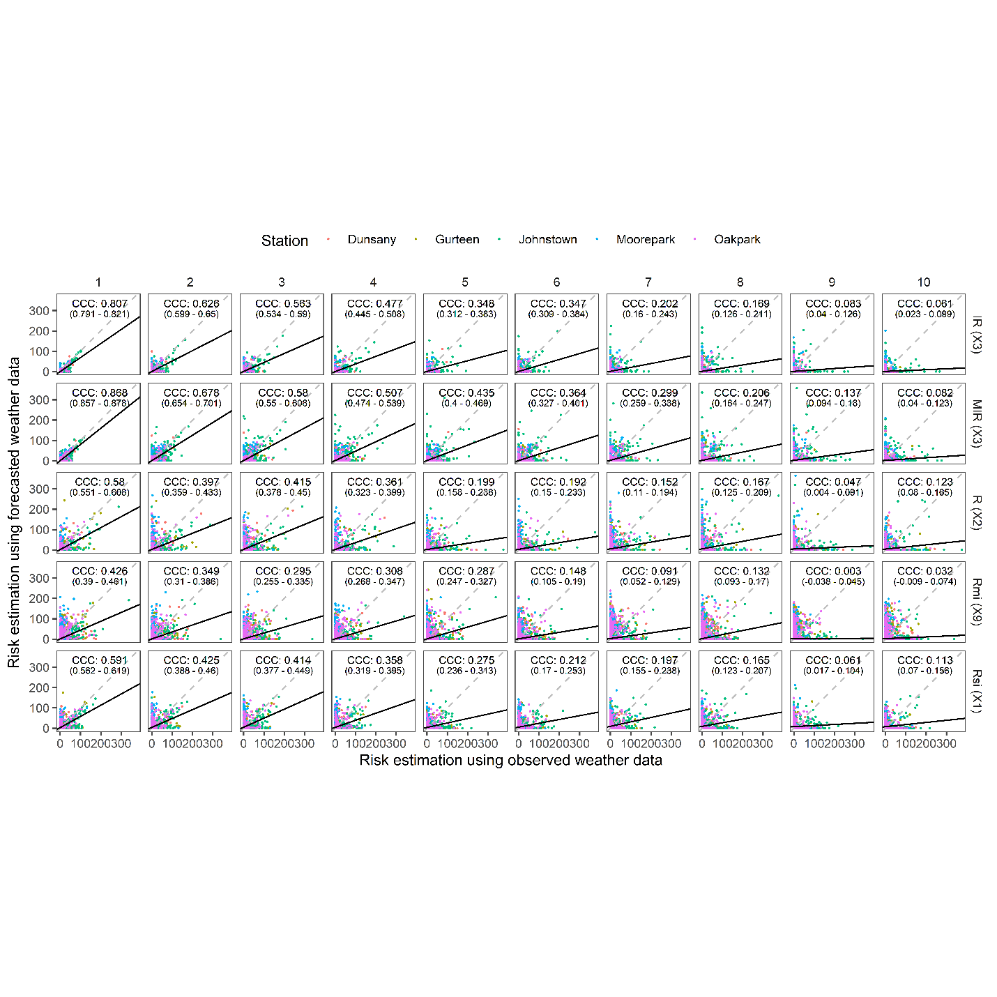

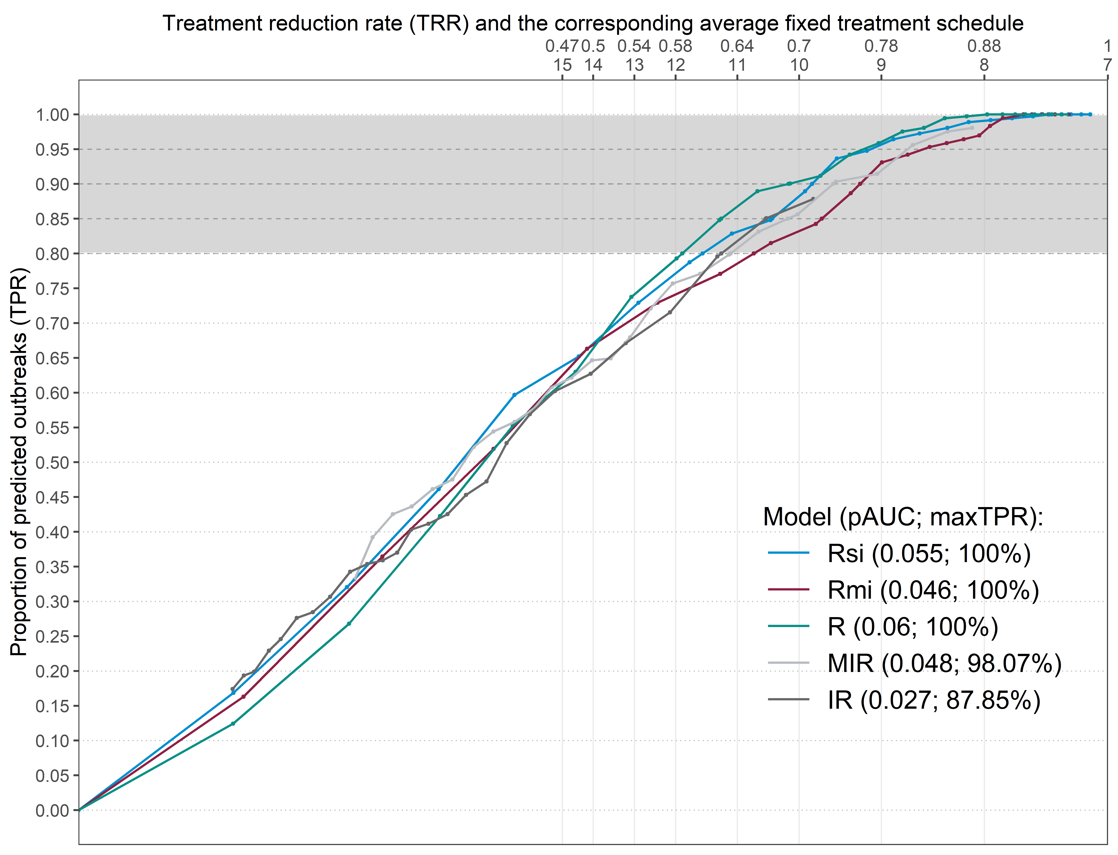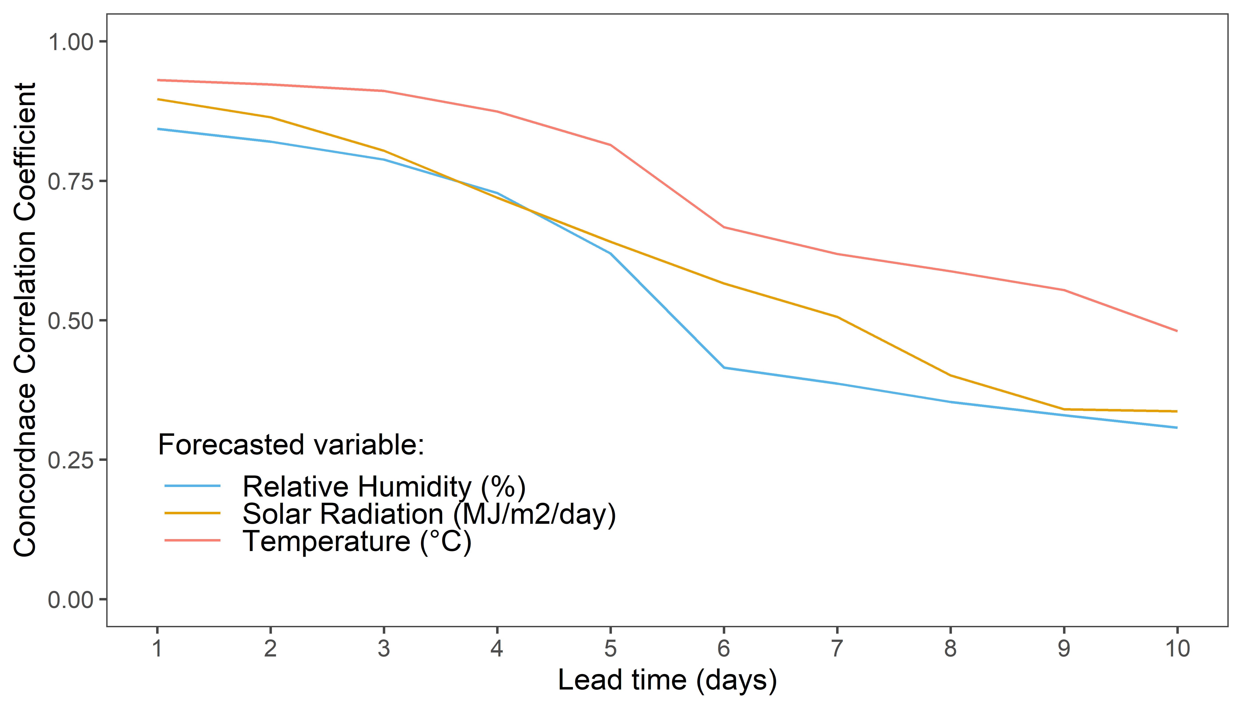

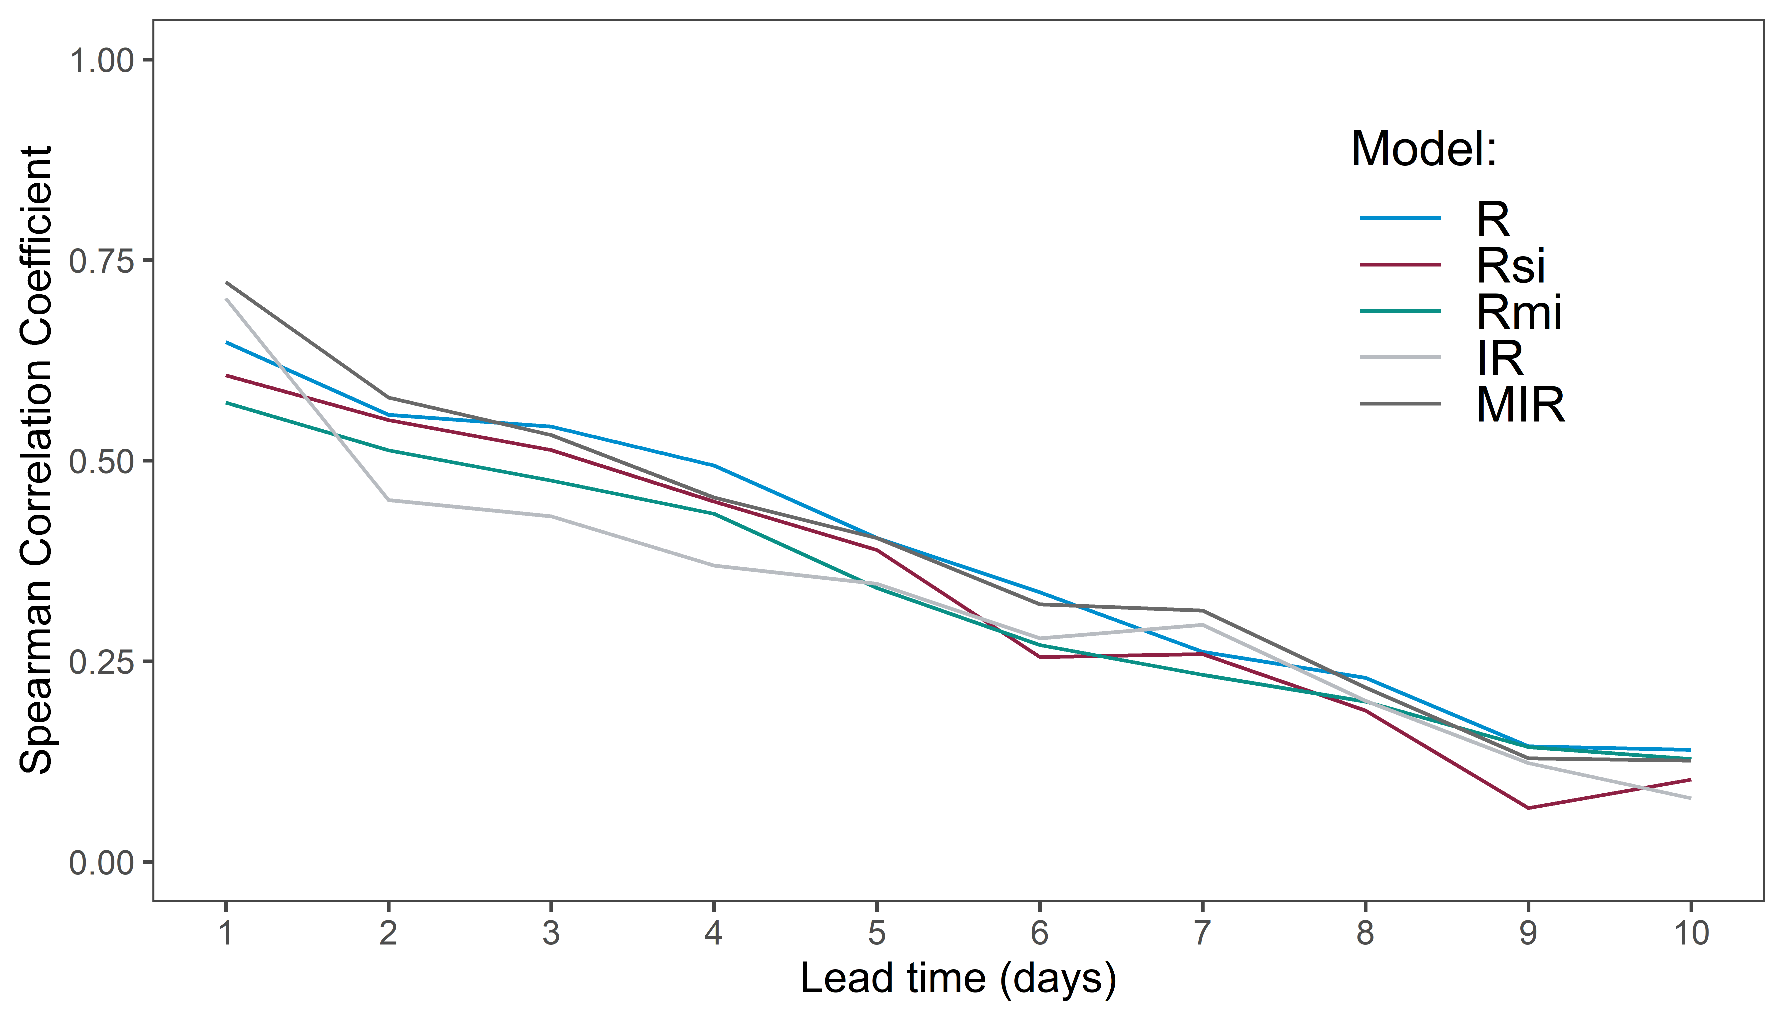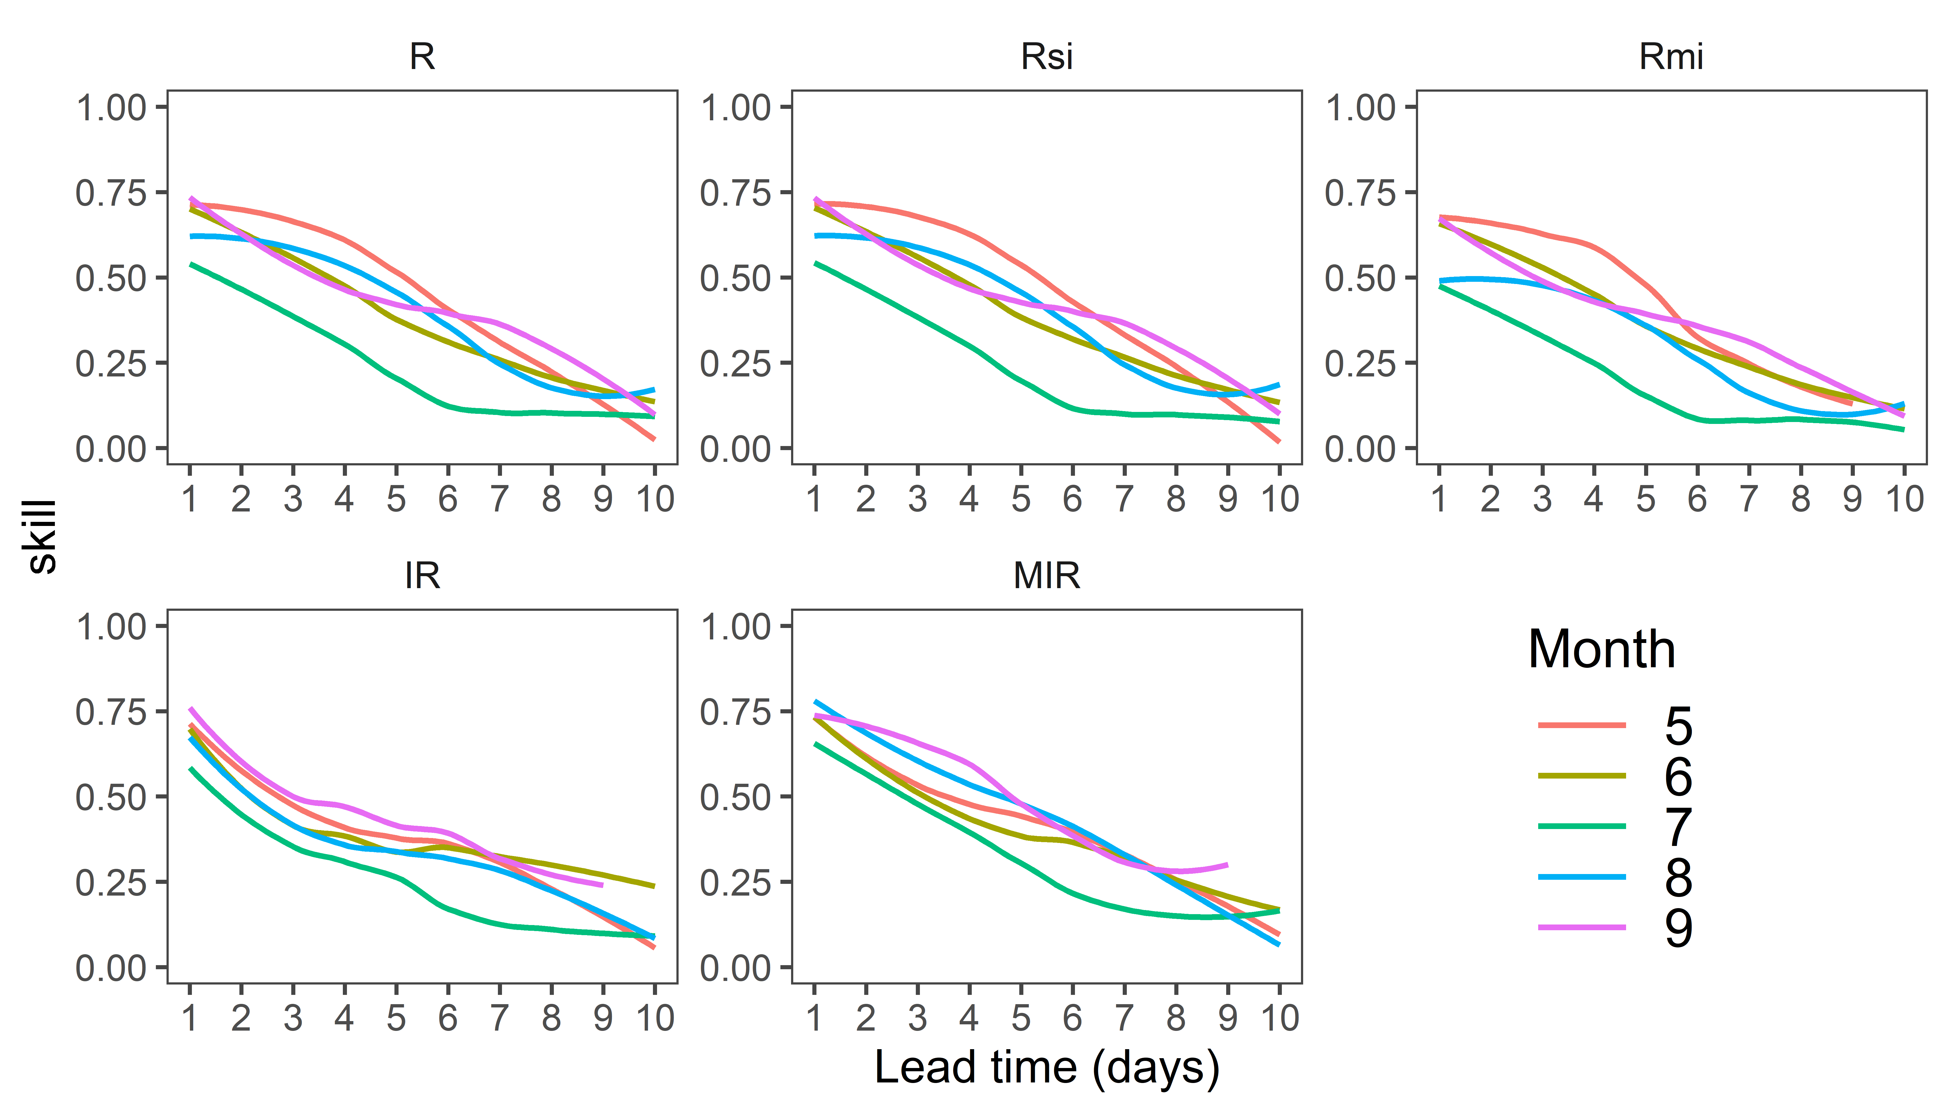

Model development

Due to its quantitative nature, the proposed models were able to cover the entire sensitivity range, offering an appealing flexibility over the crude estimation by the IR and MIR. The biological nature of the model allows an easy integration …. Necessary to establish upper temperature limit due to possible effects of climate change

Additionally, we provide an open and reproducible code for the implementation and evaluation of the proposed model

The model we proposed are developed using an adapted version of an established simple generic model .

The modeling platform can easily be supplemented with the fungicide degradation model as well as crop phenology model for the purpose of further model evaluation. However, the application of these is not realistic on the intedned purpose of this model and hence would not be further considered.

Results of out previous research indicate a need flexible pathogen threshold estimation over the course of the year. Andrivion - tradeoffs between pahogenicity and survival. Tempral structure of the pathogen population changes

Parametrisationusing the Crosier data might have led to

The model is parametarised mostly relied on the data by Crosier….. Reparametarisation using the more comprehensive biological data set could lead to improved model performance.

Such approach might lead to improved integrated control in manageing pathogen evolution

Model performance

Although our results did not show major differences after including the the *Rfact*, we believe that this parameter should be used when using the bet function to model multiple life stages of the pathogen, due to possible differences in the overall risk contribution of each life stage.

The new model showed improvement over both the original and modified Irish Rules, in terms of the diagnostic performance. .The model is better but needs further validation (field and more/better data)

Adding weather variables to models might improve the diagnostic performance, but it also multiplies the uncertainty introduced by each forecasted weather variable. Higher the impact of mortality calculation - the lower the performance.

In case of a high fungicide treatment frequency crop disease, such as PLB, the treatment decision would most often depend on the forecasted weather data. Hence, the usual practice in development of models based solely on historical data is unacceptable in this case.

The anomalies seen in the temperature and relative humidity during the morning and evening hours could contribute to overall disease risk precision contribution. The low RMSE variations in the temperature with an overall acceptable CCC for the first four lead days

The Irish pathogen population is simple with only a few clonal genotypes.

Our previous research indicated that the pathogen population is shifting towards the end of the season. This shift is even more expressed during the years with very conducive blight weather. Such conditions provide the conditions for uninterrupted disease cycles and the fitter strains which seem to be more lethal to their hosts. The population of these strains is heavily reduced during the period between the potato growing seasons. For these reasons monitoring of the population (fry - rapid genotyping, infield genotyping, and carrise spore traps references) and knowledge regarding the phaenological stage of the crop plays a major role in determining the level of the risk and translation into a practical advice. Such information could be integrated into the

The reproducibility of the model and evaluation platform allows the model to be employed worldwide. However, we call for caution regarding the assumptions employed in the model development and operational application characteristic to the Irish potato late blight pathosystem and meteorological network ability.

In the era of re-emerging and new crop diseases, threatening global crop security, ever-decreasing number of new plant pathologists need to use all the tools available to achieve sustainable disease management (Saunders et al., 2019).

The letter to an editor

Here we present the first reproducible report on the development implementation of the crop disease risk prediction model implementation and the evaluation using a single free-of-charge programming platform. Such an approach allows an open and ongoing evaluation, validation and update of the model algorithm and decision strategy under Irish conditions and elsewhere and integration of the new scientific findings and transferability to any potato late blight pathosystem. We deem such approach necessary due to increasing knowledge of the pathosystem,

Discussion :

Sensitivity – pay attention to those very sensitive and further research

 The importance of preserving the potato late blight varietal resistance durability has received increasing emphasis in theoretical (e.g. Skelsey et al., 2007) as well as applied research (e. g. Kessel et al., 2018).

Sustaining the activity may hinge upon continued dialogue and collaboration between the four core groups – Meteorologist, Research, Extension and the end-user.

Acquiring denser data would help better prediction - reproducibility is important

The diagnostic performance of all models should be interpreted with a degree of caution. It is possible that some of the reported outbreaks in these data did not result from the dispersion of inoculum originating from a distant source, but from an inoculum originating from primary sources within the crop, such as volunteer potatoes, oospores or refuse piles or from the infected seeds. This could have caused a lower diagnostic performance of the proposed models because one of their intended purpose is risk prediction on the synoptic level, with the assumption that the primary inoculum needs to be prod is originating from outwhere the risk estimation is based on the spore survival, in some degree. The existence of such outbreaks could also have a negative impact of the diag. performance of all models, because their

However, this leaves open the choice of decision threshold (cut-off

probability) related to decision-making in the context of crop protection, which may not be a

desirable trait in a disease risk forecasting system for some practitioners.

Model performance

The new model showed improvement over both the original and modified Irish Rules, in terms of the diagnostic performance.

Increasing complexity leads to improved diagnostic performance but also increasing uncertainty introduced by the weather forecast.

Adding weather variables to models might improve the diagnostic performance, but it also multiplies the uncertainty introduced by each forecasted weather variable.

The anomalies seen in the temperature and relative humidity during the morning and evening hours could contribute to overall disease risk.

The low RMSE variations in the temperature with an overall acceptable CCC for the first four lead days

The Irish pathogen population is simple with only a few clonal genotypes.

Our previous research indicated that the pathogen population is shifting towards the end of the season. This shift is even more expressed during the years with very conducive blight weather. Such conditions provide the conditions for uninterrupted disease cycles and the fitter strains able to overcome higher levels of resistance. The population of these strains is heavily reduced during the period between the potato growing seasons. For these reasons monitoring of the population (fry - rapid genotyping, infield genotyping, and carrise spore traps references) and knowledge regarding the phaenological stage of the crop plays a major role in determining the level of the risk and translation into a practical advice. Such information could be integrated into the

The reproducibility of the model and evaluation platform allows the model to be employed worldwide. However, we call for caution regarding the assumptions employed in the model development and operational application characteristic to the Irish potato late blight pathosystem and meteorological network ability.

.

Rafael

DayINF in schematics and formulas